**Assignment: 1**

**Understanding of Hardware and Its Comp:**

**Section 1: Multiple Choice**

1. Which of the following is NOT a component of the CPU?

1. ALU 2. RAM 3. CU 4. 1 and 3 both

2. What is the function of RAM in a computer?

- RAM (Random Access Memory) serves as the computer’s working memory. It stores data that the CPU needs to access quickly while running programs. Unlike permanent storage (like hard drives), RAM is volatile and loses its data when the computer is powered off.

3. Which of the following is a primary storage device?

1. HDD 2. SSD 3. SD card 4. 1 and 2 both

4. What is the purpose of a GPU?

* A Graphics Processing Unit (GPU) is designed to handle complex graphics and parallel processing tasks. It accelerates rendering, video playback, and other visual computations, especially in gaming and multimedia applications

**Section 2: True or False**

5. True or False: The motherboard is the main circuit board of a computer where other components are attached = TRUE

6. True or False: A UPS (Uninterruptible Power Supply) is a hardware device that provides emergency power to a load when the input power source fails = TRUE

7. True or False: An expansion card is a circuit board that enhances the functionality of a component = TRUE

Section 3: Short Answer

8. Explain the difference between HDD and SS

**HDD (Hard Disk Drive):**

* + **Technology:** HDDs use spinning disks (platters) coated with a magnetic material and a read/write head to access data.
  + **Storage Mechanism:** Data is stored on the spinning disk’s surface.
  + **Features:**
    - High storage capacity (up to 16TB).
    - Lower cost.
    - Larger physical size.
    - Slower performance due to mechanical parts.
    - Durability limitations.

**SSD (Solid State Drive):**

* + **Technology:** SSDs use flash memory (no moving parts) to store data.
  + **Storage Mechanism:** Data is stored on instantly-accessible memory chips.
  + **Features:**
    - Faster performance (shorter read/write time).
    - Compact size (ideal for laptops and tablets).
    - Lower power consumption.
    - More durable (no mechanical parts).

**9. Describe the function of BIOS in a computer**

BIOS stand for BASIC INPUT/OUTPUT Device

1. **Initialization:** When you turn on your computer, BIOS initializes essential hardware components such as the RAM, processor, keyboard, and hard drive. It ensures they are configured correctly for the system to function.
2. **Boot Process:** BIOS checks the CMOS settings (user-configured settings) and decides which device the system will boot from (e.g., hard drive, USB, CD-ROM). It then loads the operating system into memory.
3. **Hardware Diagnostics:** BIOS performs self-tests on hardware during startup. If any issues are detected, it provides error messages or beeps to alert the user.
4. **System Services:** BIOS provides runtime services for the operating system and programs. It handles low-level tasks like reading from and writing to storage devices, managing input/output, and interacting with connected peripherals.

**Section 4: Practical Application**

10. Identify and label the following components on a diagram of a motherboard:

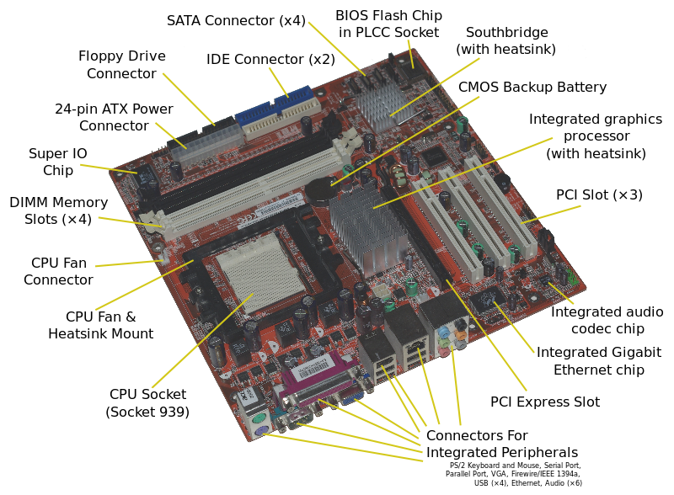

**11. How to install RAM module into a computer ?**

1. **Gather Supplies:**
   * Clear your workspace and make sure it’s static-safe.
   * You’ll need your desktop computer, Crucial® desktop memory, a screwdriver, and the owner’s manual.
2. **Shut Down Your Desktop Computer:**
   * Your files and data on the storage drive won’t be affected during this process.
3. **Unplug the Power Cable:**
   * Disconnect any cables and accessories from the computer.
4. **Hold the Power Button for 5 Seconds:**
   * This discharges any residual electricity.
5. **Open the Case:**
   * Consult your computer’s owner’s manual for specific instructions.
   * Take pictures as you work to remember cable and screw placements.
6. **Ground Yourself:**
   * Touch an unpainted metal surface to prevent static damage.
7. **Remove Existing Memory Modules:**
   * Press down on the clips on the sides of each module to release it.
   * Pull the module out.
8. **Install the New Memory:**
   * Align the notches on the module with the ridge in the slot.
   * Apply even pressure and firmly press the module in until it clicks.
   * Some systems require matched pairs; follow any labeling instructions.
9. **Close the Computer Case:**
10. **Plug in the Power Cable:**
    * Your memory is now installed

**Section 5: Essay**

**13. Discuss the importance of proper cooling mechanisms in a computer system. Include examples of cooling methods and their effectiveness.**

1. **Importance of Proper Cooling**:
   * **Performance Optimization**: Efficient cooling ensures that components (such as the CPU and GPU) operate within safe temperature ranges. Overheating can lead to performance throttling, FPS drops, and system instability.
   * **Hardware Longevity**: Consistent overheating can damage components over time. Proper cooling extends the lifespan of your gaming rig.
   * **Stability**: Stable temperatures prevent sudden shutdowns or crashes during intense gaming sessions.
2. **Cooling Methods**:
   * **Air Cooling**:
     + **Pros**: Simple, cost-effective, and low maintenance. Common in computers, motor vehicles, and electronics.
     + **Cons**: Bulkier, less efficient at extreme cooling, and noisier under load.
   * **Water Cooling**:
     + **Pros**: Superior heat dissipation. Effective for high-performance systems (gaming PCs, data centers).
     + **Cons**: Higher initial cost, requires maintenance, and rare risk of leakage.
     + **Evaporative Cooling**:
     + **Pros**: Uses water evaporation for cooling. Efficient in dry, hot climates (cooling towers, swamp coolers).
   * **Thermoelectric Cooling**:
     + **Pros**: Precise temperature control (optical devices, medical equipment).
     + **Cons**: Requires electricity, less common.
   * **Phase Change Cooling**:
     + **Pros**: Fluid transitions from liquid to vapor, absorbing large heat amounts.
3. **Considerations**:
   * **Budget**: Choose based on financial comfort.
   * **Compatibility**: Ensure compatibility with other hardware.
   * **Noise Levels and Aesthetics**: Consider your environment.

**14. Explain the concept of bus width and its significance in computer architecture**.

Bus Width and Its Significance in Computer Architecture

Bus Width:

- Definition:* Bus width refers to the number of bits that can be transmitted simultaneously over a computer bus. The bus is a communication system that transfers data between components inside or between computers.

- Measured In: Bits (e.g., 8-bit, 16-bit, 32-bit, 64-bit).

Significance:

1. Data Transfer Rate:

- The bus width directly affects the data transfer rate. A wider bus can carry more data at once, which increases the overall speed of data transfer between components.

- For example, a 64-bit bus can transfer 64 bits of data in a single cycle, while a 32-bit bus can transfer only 32 bits.

2. Performance:

- Wider buses contribute to better performance, as they allow more data to be processed simultaneously. This is crucial for tasks that require high-speed data access and transfer, such as gaming, video editing, and large-scale computations.

- CPUs with wider buses can access memory more quickly and efficiently, reducing bottlenecks and improving overall system performance.

3. Memory Addressing:

- Bus width also determines the maximum addressable memory. A 32-bit system can address up to 4 GB of RAM (2^32 addresses), while a 64-bit system can address significantly more memory (up to 16 exabytes, 2^64 addresses), making it suitable for modern applications requiring large amounts of memory.

4. Compatibility:

- The bus width must be compatible with other system components such as the CPU, memory, and peripherals. Incompatible bus widths can lead to inefficiencies or the inability to utilize the full potential of the components.

5. System Complexity and Cost:

- Wider buses may increase system complexity and cost due to the need for more pins, traces on the motherboard, and more sophisticated design considerations.

- There is a trade-off between the benefits of increased bus width and the additional cost and complexity it introduces.